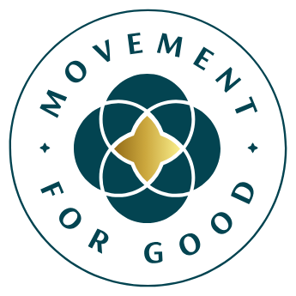

[Insert date]

**Help [Insert name of charity] secure £5,000**

**from Benefact Group**

**[Your charity] is calling for nominations to receive a £5,000 Movement for Good Award from Benefact Group.**

[Your charity] is calling on members of the public to nominate them for a chance to be awarded £5,000 as part of Benefact Group’s Health & Wellbeing Special Draw, which will award a share of £50,000 to ten charities working in this area.

Benefact Group’s annual Movement for Good Awards gives over £1million away to charities and good causes.

**How to nominate:** The nomination window for health and wellbeing charities is open between Monday 28 April to Sunday 4 May. It’s quick and easy to nominate [your charity] online at <https://health.movementforgood.com>

**Why nominate [your charity]:** Each nomination gives [your charity] a better chance of being selected as one of the lucky winners. If they win, they plan to[Insert information about how your charity will spend the £5,000 if they win and how it will make an impact]. They’re encouraging everyone to use their social media channels to spread the word and ask loved ones to nominate them too. Winners will be drawn at random and the more times [your charity] is nominated the more chance it has of being selected.

[Insert quote from your charity spokesperson which highlights the great work your charity does and encourages people to nominate them].

**Mark Hews, Group Chief Executive of** [**Benefact Group**](https://benefactgroup.com/)**, said:** *“Benefact Group is a family of award-winning specialist financial services companies and the third largest corporate donor to charity in the UK. Owned by a charity ourselves, charitable giving is at the heart of what we do.* *All of our available profits go to good causes and the more we grow, the more we can give.*

*“We’re delighted to be able to donate over £1million to good causes each year through our Movement for Good Awards and we know that for many health and wellbeing charities, £5,000 can make a real difference.”*

Movement for Good is funded by EIO plc, part of the Benefact Group.

**\*\*\*ENDS\*\*\***

**Notes for editors**

**Contact details**[Who should the journalist contact for more information]

**About [your charity]**

[Use this space to include some information about your charity, bullet point the information and don’t have more than two or three points here]. For more information visit [insert your web address]

**About the Movement for Good Awards**

Benefact Group’s Movement for Good Awards is giving away £1,120,00 to help charities change lives for the better in 2025.

£350,000 will be donated in £1,000 grants throughout the year. The £1,000 awards are open to all UK-registered charities, not-for-profit organisations, or community interest companies. Anyone can nominate at any time for the chance to receive £1,000.

£200,000 will be donated in £5,000 special grants throughout the year.

£400,000 will be donated in larger amounts throughout the year.

£120,000 will be distributed in December as part of the 12 Days of Giving initiative.

£50,000 has been allocated for charities in an exciting new and innovative way called Pay It Forward.

Movement for Good is funded by EIO plc, part of the Benefact Group.

For more information visit [www.movementforgood.com](http://www.movementforgood.com/)

**About Benefact Group**

Benefact Group is a specialist financial services organisation with a unique mission: to donate all its available profits to charity. As an independent group owned by the registered charity Benefact Trust, its diverse family of businesses - including Ecclesiastical Insurance - offers expertise in specialist insurance, investment management, and broking and advisory services across the UK, Australia, Canada, and Ireland.

Over the past decade, Benefact Group has established itself as the third-largest corporate contributor to charitable causes in the UK, donating over £250m to charities since 2014. Find out more here: [www.benefactgroup.com](http://www.benefactgroup.com/)